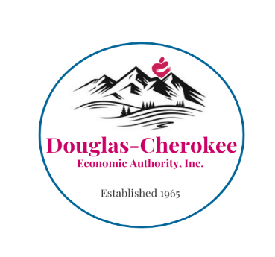

**DOUGLAS-CHEROKEE ECONOMIC AUTHORITY**

**LIHEAP – ENERGY ASSISTANCE PROGRAM**

**PUBLIC NOTICE**

**This notice is to advise you that the State of Tennessee has delayed the start of the**

**2026 LIHEAP Program Year until November this year.**

**NO LIHEAP APPLICATIONS WILL BE AVAILABLE FROM OR ACCEPTED BY DCEA IN OCTOBER**

This delay is due to a database transfer and the timing of release of funds from HHS.

**LIHEAP has not been cut. Remaining 2025 funds will be available in November.**

**It is possible 2026 funding may be delayed further by the government shut down.**

**Once LIHEAP intake begins on November 1st, applicants will be required to complete the application process online. Please monitor DCEA-LIHEAP.org and DCEA on Facebook for updates. The link to the online application portal will be posted there as soon as it is available. DCEA offices and staff will be available to assist you with that process at that time.**

We urge you to keep your utility and heating fuel bills paid to avoid any disconnection of services or lack of heating fuel. Only limited emergency assistance will be available through other funding sources until LIHEAP begins, so please call ahead to your local Neighborhood Service Center if you have an unexpected, uncontrollable situation that puts you in danger of having your electric disconnected, or prevents you from purchasing heating fuel.

DCEA recognizes that this delay may cause inconvenience and appreciates your patience as these program adjustments are implemented Statewide.

